**🏠 HouseHunt – Final Project Report**

**1. INTRODUCTION**

**1.1 Project Overview**

HouseHunt is a MERN-stack based rental property platform that connects renters, property owners, and administrators. Users can search and browse rental homes, send inquiries, and track responses. Property owners can manage their listings and bookings via a dedicated dashboard, while admins verify and promote trusted properties and manage platform activity.

**1.2 Purpose**

To build a full-featured, real-time rental home platform with role-based access for renters, property owners, and admins, offering intuitive UI/UX and secure data handling.

**2. IDEATION PHASE**

**2.1 Problem Statement**

Many students, job seekers, and families in semi-urban areas struggle to find suitable rental homes. How might we simplify and digitize the house rental process for both renters and property owners?

**2.2 Empathy Map Canvas**

Who are we empathizing with?  
Renters (students, professionals) and local property owners.

**What do they see/hear/do/feel?**

* **See:** Scattered listings, outdated contacts
* **Hear:** Delays in communication, no proper verification
* **Do:** Visit properties physically, search social media
* **Feel:** Stressed, unsure, overwhelmed

**2.3 Brainstorming**

**Grouped ideas:**

* **Renter Experience:** Easy search/filter, inquiry system, favorites
* **Owner Experience:** Property management, inquiry responses
* **Admin Needs:** Dashboard, listing verification and promotion

*Used sticky notes and grouping techniques during Mural ideation.*

**3. REQUIREMENT ANALYSIS**

**3.1 Customer Journey Map**

1. Visit homepage → 2. Browse listings → 3. Filter/search →
2. Login/Signup → 5. Send Inquiry → 6. Track Response → 7. Save Listing

**3.2 Solution Requirements**

**Functional:**

* Sign up/login
* View/filter properties
* Send booking inquiry
* Listing management by owners
* Admin verification and promotion

**Non-Functional:**

* Secure, scalable, responsive interface
* Token-based login
* Modular, role-based access

**3.3 Data Flow Diagram**

Level-0 DFD includes:

* Actors: Renters, Owners, Admins
* Processes: Auth, Inquiry, Property Listing, Admin Promotion
* Data Stores: MongoDB (Users, Listings, Bookings)

**3.4 Technology Stack**

* Frontend: React.js
* Backend: Node.js, Express.js
* Database: MongoDB
* Security: JWT
* Architecture: 3-tier RESTful model

**4. PROJECT DESIGN**

**4.1 Problem–Solution Fit**

Aligns renter needs (quick, verified property search) with owner needs (simplified listing) using a responsive, secure platform.

**4.2 Proposed Solution**

* Role-based login (Renter, Owner, Admin)
* Smart property filtering
* Booking inquiry system
* Admin tools to verify and promote listings

**4.3 Solution Architecture**

* **UI:** React frontend
* **API Layer:** Node/Express backend
* **Database:** MongoDB

Supports modular development, scalability, and role-based dashboards.

**5. PROJECT PLANNING & SCHEDULING**

**5.1 Sprint Planning**

* 4 Total Sprints
* Sprint 1: Authentication and Homepage
* Sprint 2: Inquiry and Tracking
* Sprint 3: Owner Dashboard
* Sprint 4: Admin features and UI polish

**6. FUNCTIONAL AND PERFORMANCE TESTING**

**6.1 UAT Testing Coverage**

* Secure user and owner login
* Search/filter functionality
* Inquiry creation and status tracking
* Listing management by owners
* Admin login and promotion

All major test cases passed successfully.

**7. RESULTS**

**7.1 Output Screenshots**

* **Homepage**

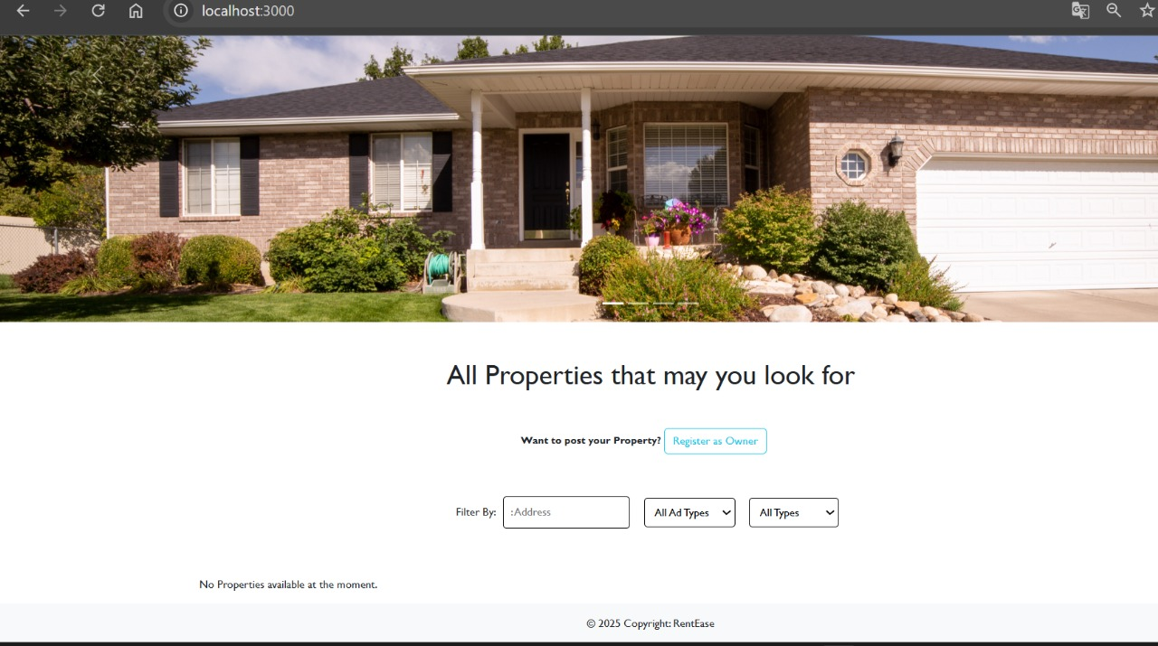

* **Login Page**

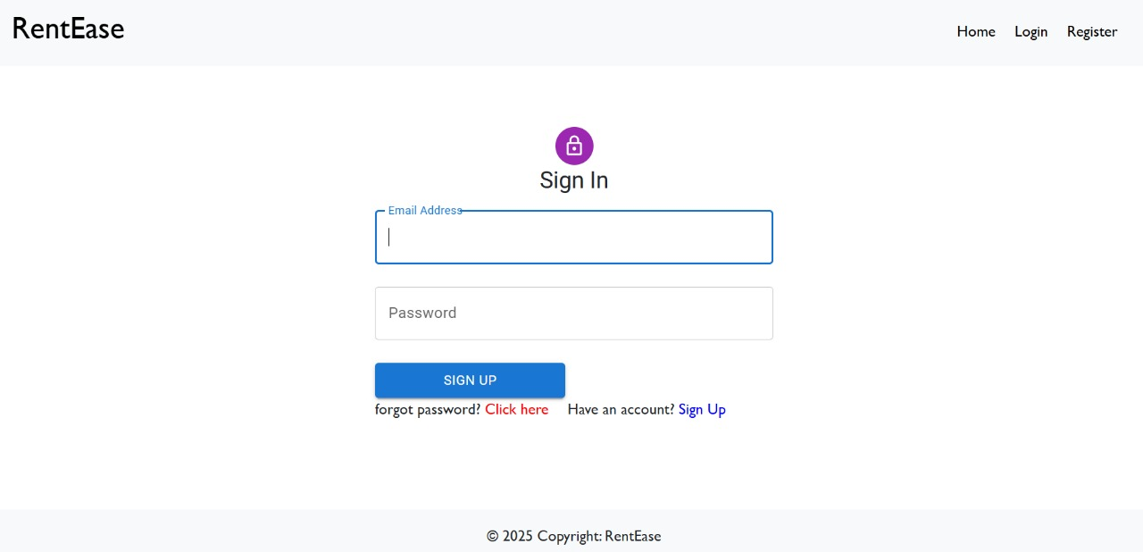

* **Registration Page**

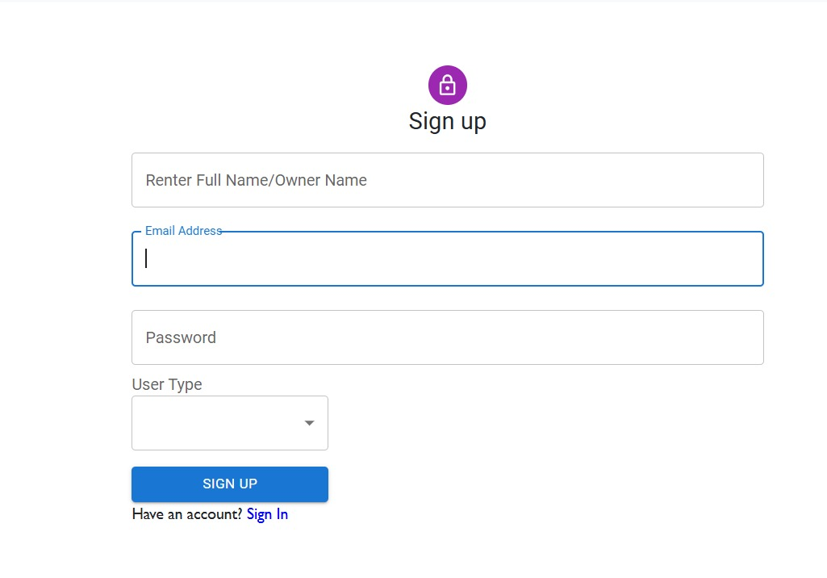

* **Booking History**

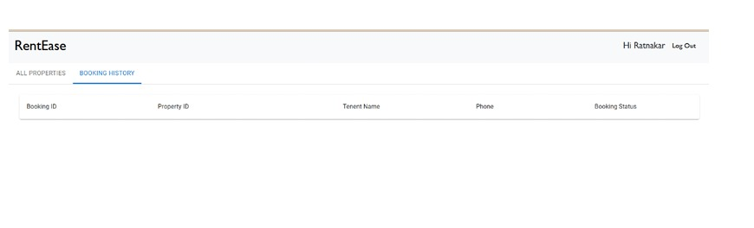

**8. ADVANTAGES & DISADVANTAGES**

**✅ Advantages:**

* Real-time inquiry system
* Separate dashboards per role
* Mobile-friendly UI
* Secure JWT login
* Admin listing control

**❌ Disadvantages:**

* No mobile app version (yet)
* Inquiry only; no direct payment or lease handling yet

**9. CONCLUSION**

HouseHunt successfully delivers a fully functional house rental platform using MERN technologies. It enables property discovery, inquiry management, admin oversight, and user-role isolation. The project meets its technical goals and provides a solid foundation for real-world deployment.

**10. FUTURE SCOPE**

* Integrate payment gateways (for rent deposits)
* Build delivery module for documents or keys
* Push/email notifications for responses
* Launch React Native mobile app
* Add analytics and reporting tools in admin panel

**11. APPENDIX**

* **Source Code:** GitHub Repository Link (to be inserted)
* **Contributors:**
  + Yedukondalu (Frontend & Inquiry Logic)
  + Sai Sri (Owner Dashboard)
  + Ruthika (Admin Panel & UI Enhancements)
  + Krishna (Search, Filters, and Booking UX)